Company Database Schema

Here is the schema of a company database, please implement it on any RDBMS you like and then try to create the following requests (queries):

Employee:
Fname | Lname | SSN | BDATE | Addresss | Gender | Salary | Superssn | Dno
Ahmed | Ali | 112233 | 1/1/1965 | 15 Ali fahmy St.Giza | M | 1300 | 223344 | 10
Kamel | Mohamed | 223344 | 15/10/1970 | 38 Mohy el dien abo el Ezz St.Cairo | M | 1800 | 321654 | 10
Hanaa | Sobhy | 123456 | 18/3/1973 | 38 Abdel Khalik Tharwat St. Downtown.Cairo | F | 800 | 223344 | 10
Amr | Omran | 321654 | 14/9/1963 | 44 Hilopolis.Cairo | M | 2500 | null | null
Noha | Mohamed | 968574 | 1/2/1975 | 55 Orabi St. El Mohandiseen .Cairo | F | 1600 | 321654 | 20
Edward | Hanna | 512463 | 19/8/1972 | 18 Abaas El 3akaad St. Nasr City.Cairo | M | 1500 | 321654 | 30
Mariam | Adel | 669955 | 12/6/1982 | 269 El-Haram st. Giza | F | 750 | 512463 | 20
Maged | Raoof | 521634 | 6/4/1980 | 18 Kholosi st.Shobra.Cairo | M | 1000 | 968574 | 30

Department
Dname | DNumber | MGRSSN | MGRStartdate
DP1 | 10 | 223344 | 1/1/2005
DP2 | 20 | 968574 | 1/3/2006
DP3 | 30 | 512463 | 1/6/2006

Works for
ESSN | Pno | Hours
223344 | 100 | 10
223344 | 200 | 10
223344 | 300 | 10
112233 | 100 | 40
968574 | 400 | 15
968574 | 700 | 15
968574 | 300 | 10
669955 | 400 | 20
223344 | 500 | 10
669955 | 700 | 7
669955 | 300 | 10
512463 | 500 | 10
512463 | 600 | 25
521634 | 500 | 10
521634 | 600 | 20
521634 | 300 | 6
521634 | 400 | 4

Project
Pname | Pnumber | Plocation | City | Dnum
AL Solimaniah | 100 | Cairo_Alex Road | Alex | 10
Al Rabwah | 200 | 6th of October City | Giza | 10
Al Rawdah | 300 | Zaied City | Giza | 10
Al Rowad | 400 | Cairo_Faiyom Road | Giza | 20
Al Rehab | 500 | Nasr City | Cairo | 30
Pitcho american | 600 | Maady | Cairo | 30
Ebad El Rahman | 700 | Ring Road | Cairo | 20

Dependent
ESSN | Dependent_name | Gender | Bdate
123456 | Hala Saied Ali | F | 18/10/1970
223344 | Ahmed Kamel Shawki | M | 27/3/1998
223344 | Mona Adel Mohamed | F | 25/4/1975
321654 | Ramy Amr Omran | M | 26/1/1990
321654 | Omar Amr Omran | M | 30/3/1993
321654 | Sanaa Gawish | F | 16/5/1973
512463 | Sara Edward | F | 15/9/2001
512463 | Nora Ghaly | F | 22/6/1976

Queries:
- Display the employee First name, last name, Salary and Department number in department 30 whose salary from 1000 to 2000 LE monthly
SELECT Fname,Lname,Salary
FROM Employee
WHERE Dno = 30 and Salary between 1000 and 2000
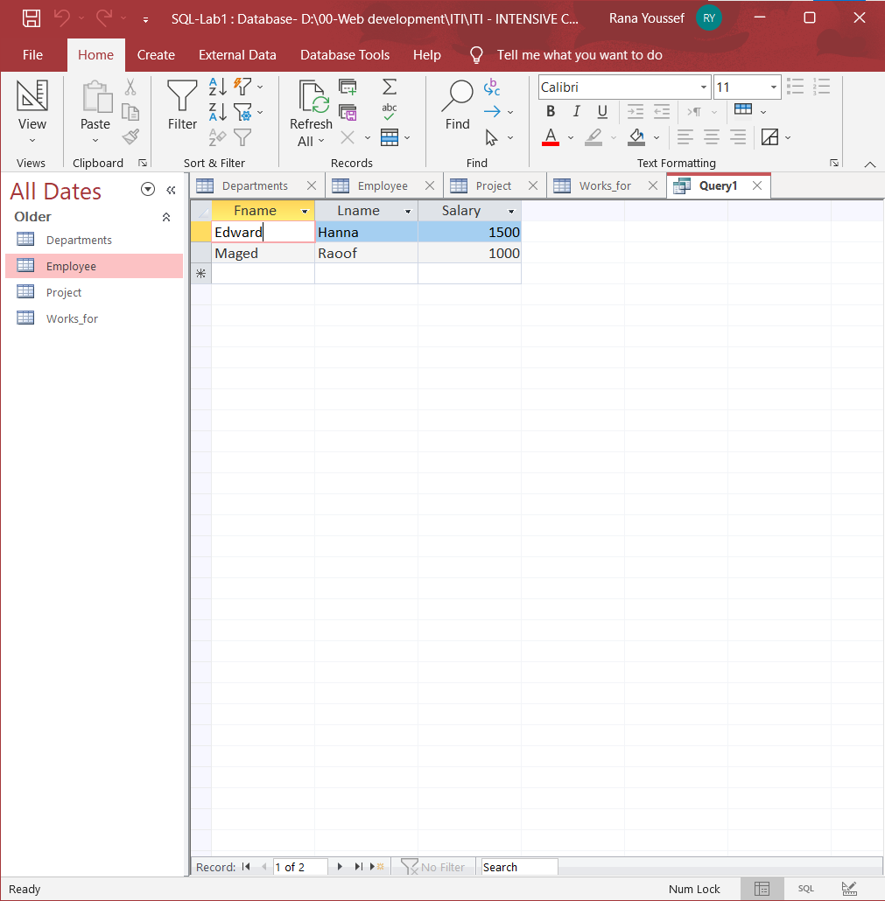
- Display all the projects names, locations and the department number which is managed by it.
SELECT Pname , Plocation , dnum
FROM Project
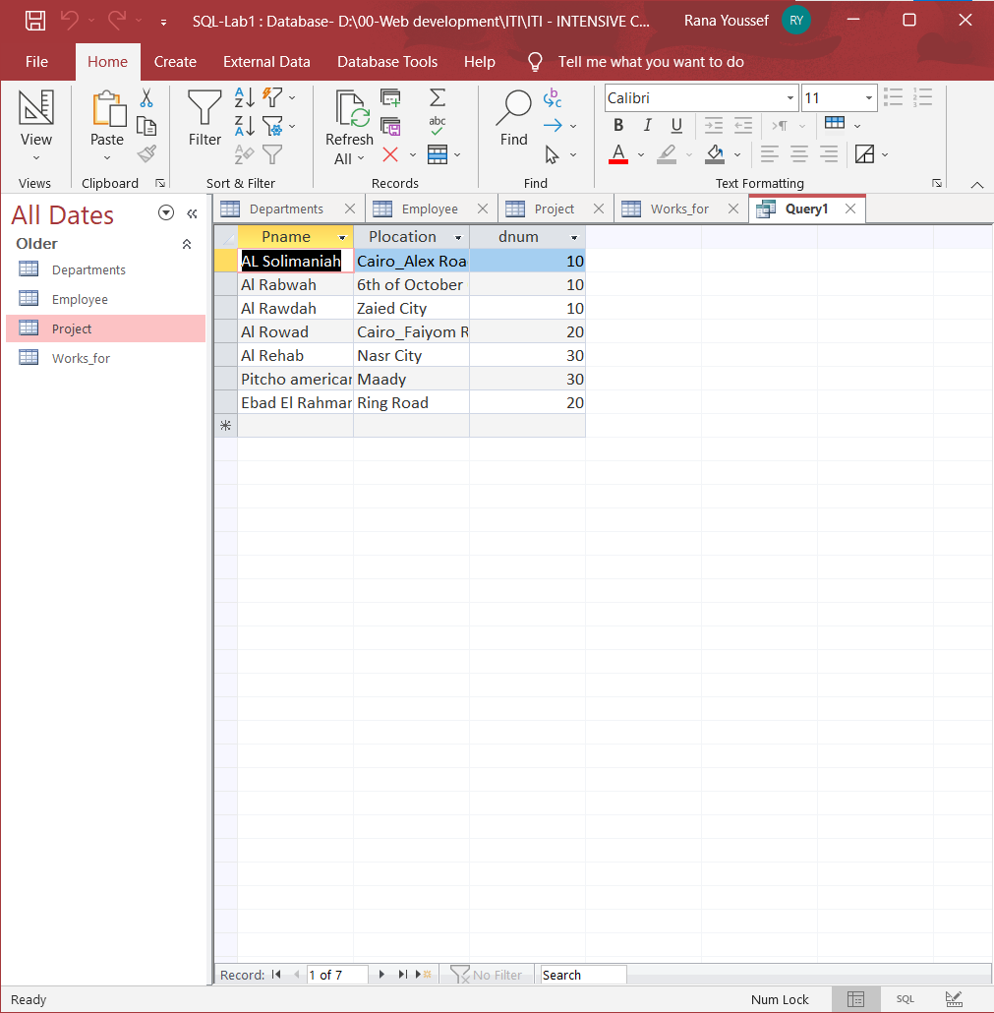

- If you know that the company policy is to pay an annual commission for each employee which specific percent equals 10% of his/her annual salary .
Display each employee full name and his annual commission in an ANNUAL COMM column (alias).
SELECT Fname + ' ' + Lname as [full name] , Salary * 0.1*12 as [ANNUAL COMM]
FROM Employee
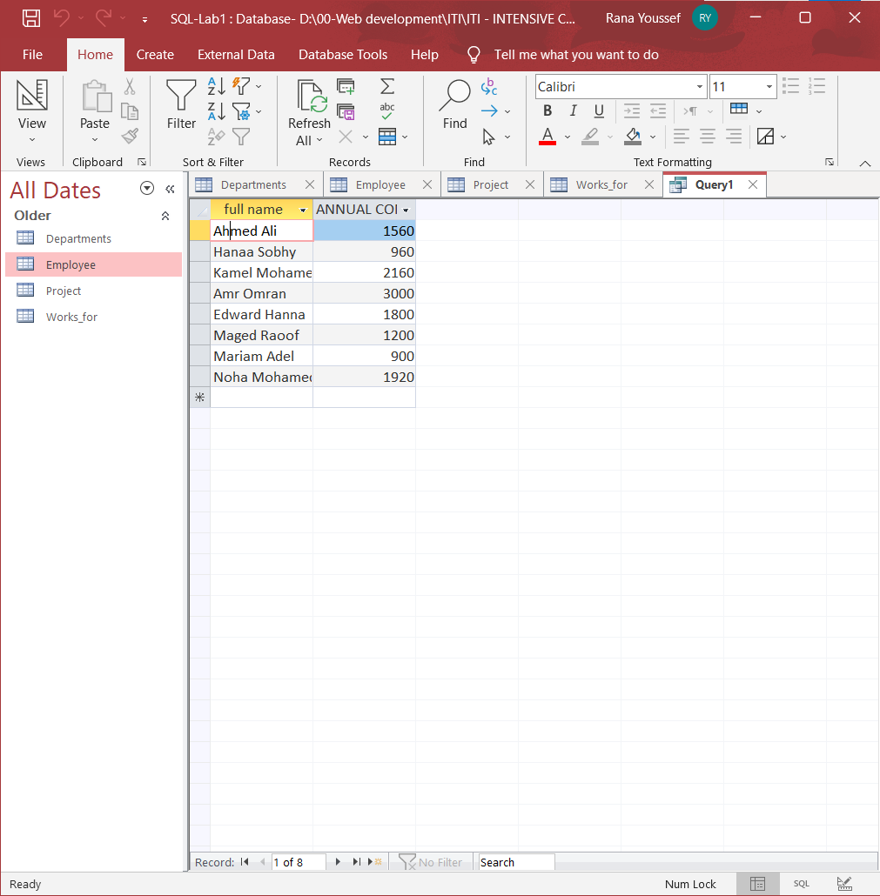
- Display the employees Id, fname who earns more than 1000 LE.
SELECT Fname , SSN
FROM Employee
WHERE Salary > 1000
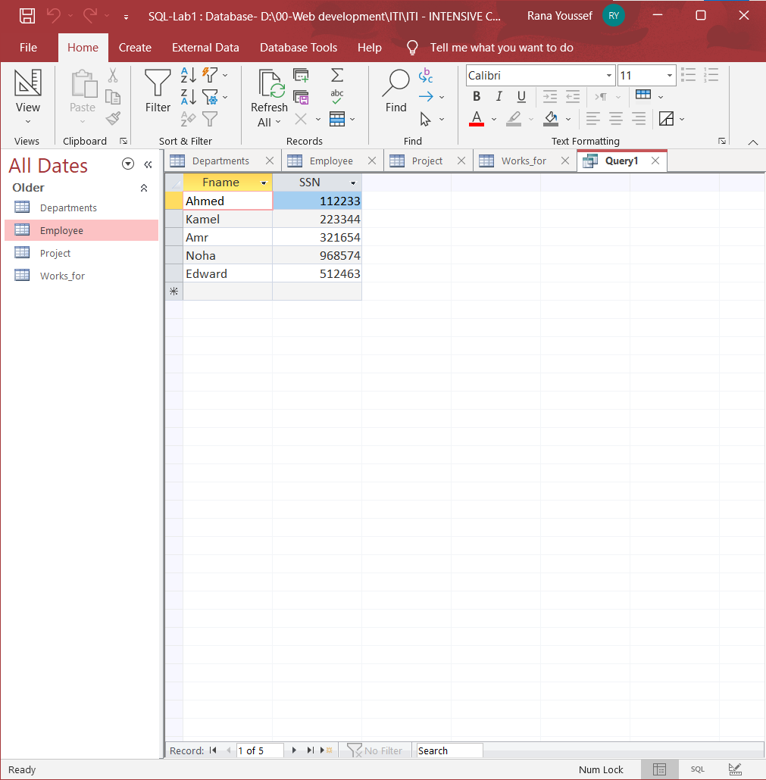

- Display the names and salaries of the female employees
SELECT Fname , Lname , Salary
FROM Employee
WHERE gender = 'F'
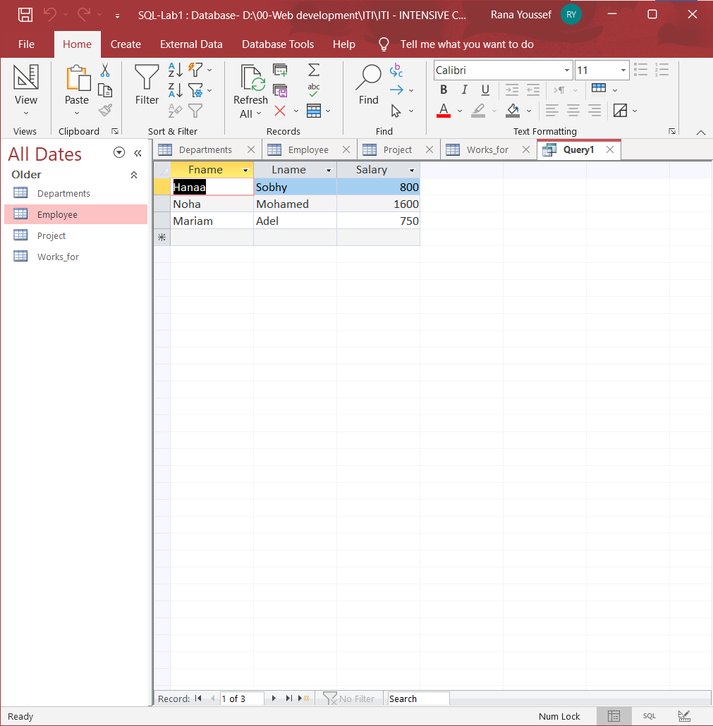

- Display each department id, name which managed by a manager with id equals 968574.
SELECT Dname , Dnum
FROM Departments
WHERE MGRSSN =968574
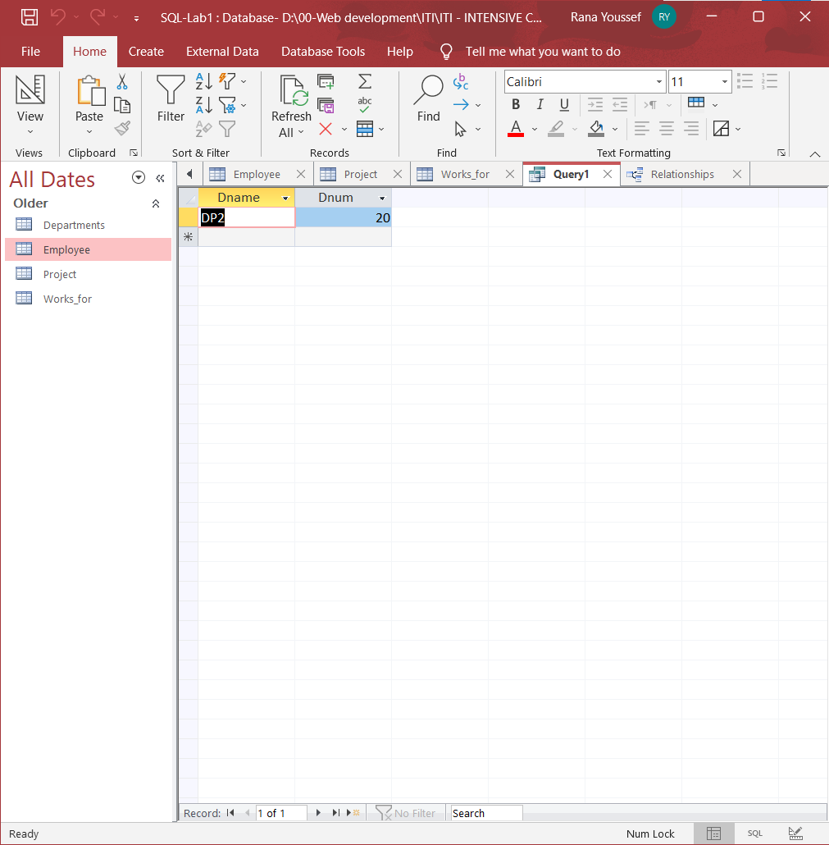
- Display the project id, name and location of the projects which
controlled with department 10 or 20,
and location of the projects in Cairo or Alex city
SELECT Pname , Pnumber , Plocation
FROM Project
WHERE Dnum IN (10 , 20) and City IN ('Cairo','Alex')
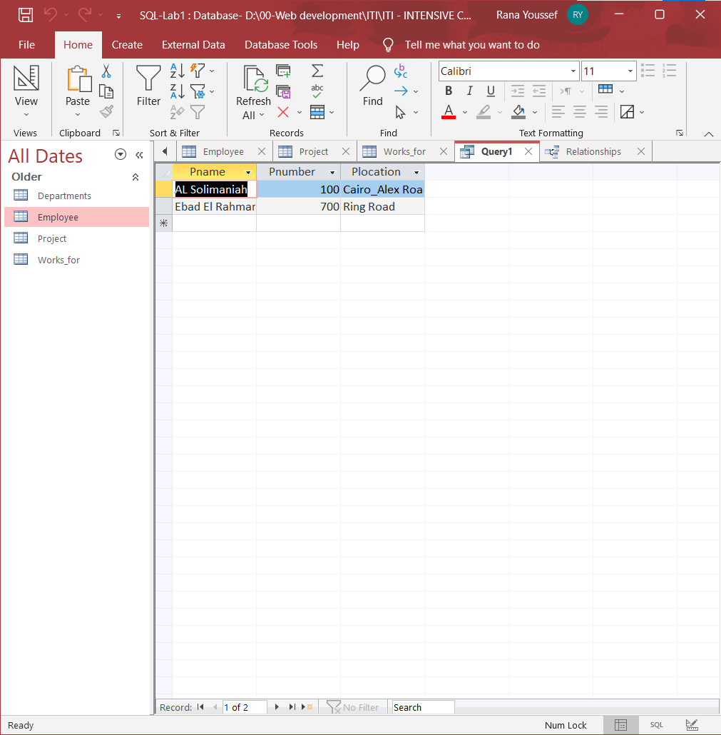
- Display the Projects name, locations of the projects with a project name starts with "p" letter.
SELECT Pname , Plocation
FROM Project
WHERE Pname like 'P*'
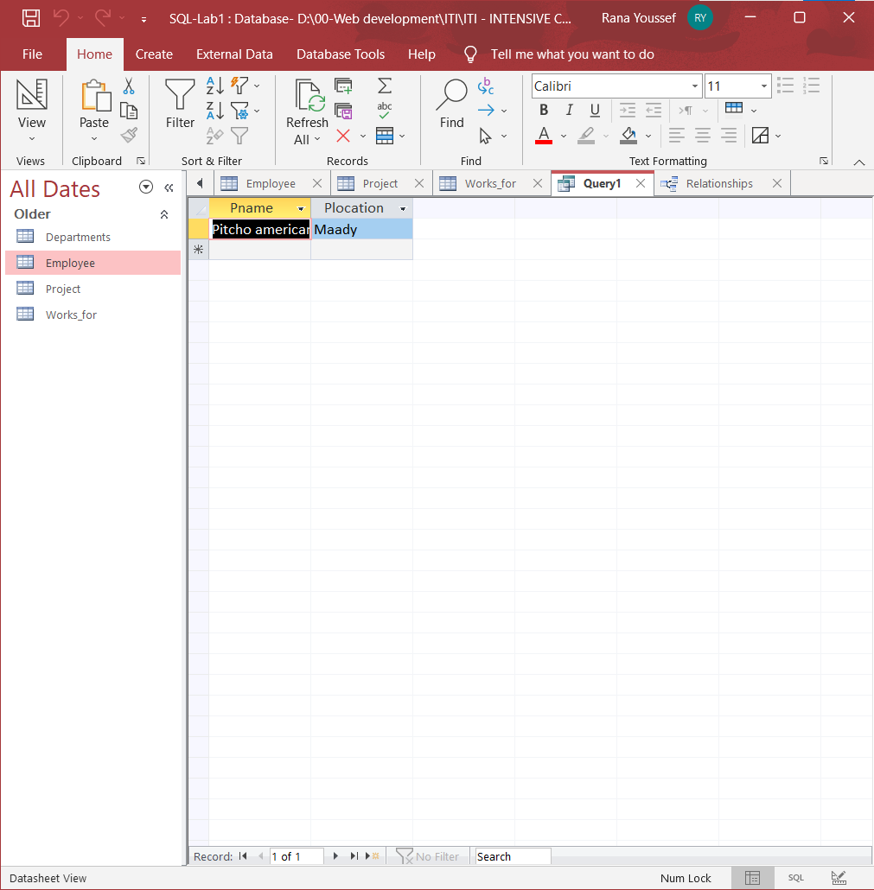

Data Definition Language:

Create the dependent table and create the relationship with employee table
Then Insert 3 rows only

CREATE TABLE dependent
CREATE TABLE Dependent (
EMP_SSN int,
Dependent_name char(50) NOT NULL,
Gender char(50) NOT NULL,
Bdate DATE,
PRIMARY KEY (EMP_SSN , Dependent_name),
CONSTRAINT FK_EmpDependent FOREIGN KEY (EMP_SSN)
REFERENCES Employee(SSN)
);
INSERT INTO Dependent Values (123456,'Hala Saied Ali','F', '18/10/1970');

INSERT INTO Dependent Values (223344,'Mona Adel Mohamed','F', '25/4/1975');

INSERT INTO Dependent Values (223344,'Mona Adel Mohamed','F', '25/4/1975');
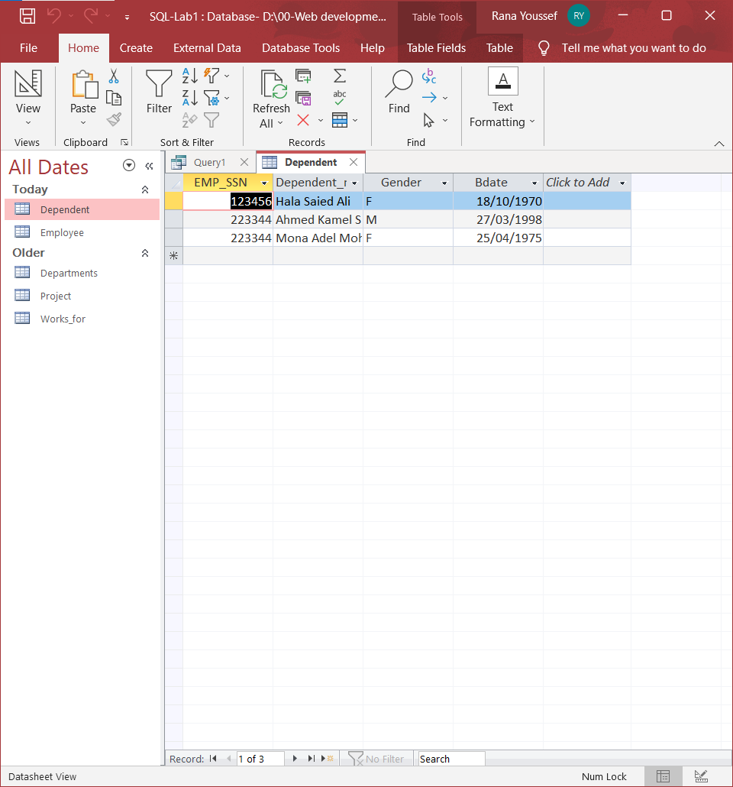

Data Manipulating Language:
- Insert new employee with your personal data, you will be in department number 30, your SSN = 666666 & Superssn = 112233.

INSERT INTO employee Values (
'Rana',
'Youssef',
666666,
'07/07/1997',
'23 Cairo st. Sedi Beshr',
'F',
2000,
112233,
30)
- Insert another employee with personal data your friend as new employee in department number 30 , SSN = 555555, but don’t enter any value for salary or manager number to him.

INSERT INTO employee (
Fname ,
Lname,
SSN,
Bdate,
Address,
gender,
Dno
)
VALUES (
'Haidy',
'Youssef',
555555,
'08/03/1995',
'23 Ahmed Fathy st. Gleem',
'F',
30)
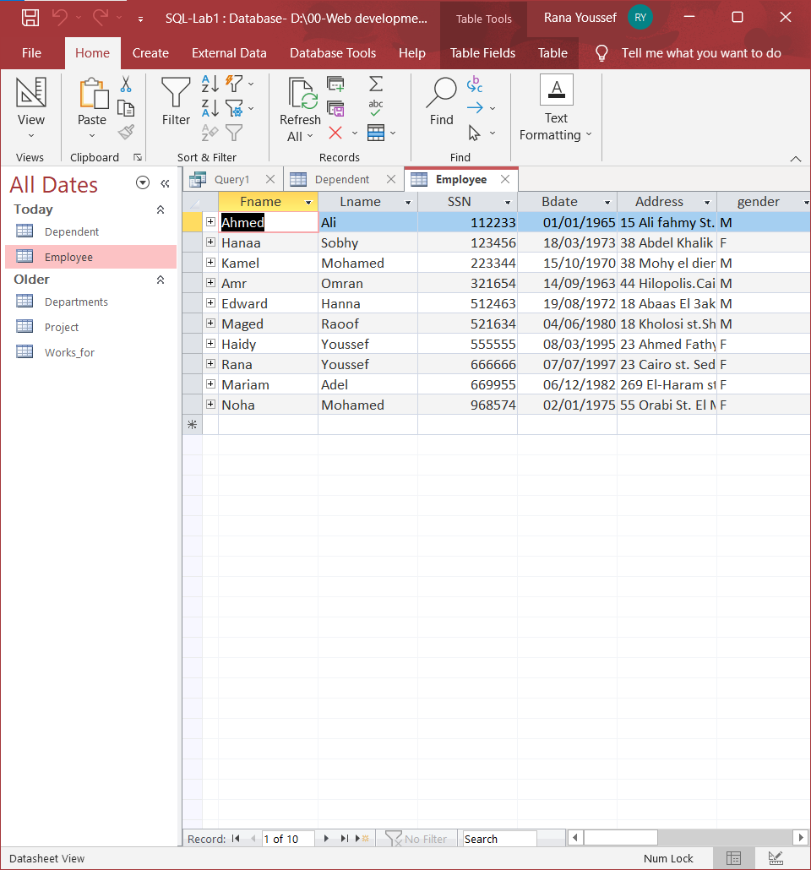
- In the department table insert new department called "DEPT IT" , with id 100, MgrSSN = 112233 as a manager for this department. The start date for this manager is '08/12/2006'

INSERT INTO Departments VALUES (
'DEPT IT',
100,
112233,
'08/12/2006')

- Do what is required if you know that : Mrs.Noha Mohamed moved to be the manager of the new department (id = 100), and they give her position to your friend
Steps:
  - Your friend will be the manager of Dept 20 (her previous department)
  - Update her record in your database to be a manager of department 100
  - Update your friend data, add yourself as a supervisor for him (supervised by you)
UPDATE Employee
SET Dno = 100
WHERE SSN = 968574

UPDATE Employee
SET Dno = 20
WHERE SSN = 555555

UPDATE Departments
SET MGRSSN = 555555
WHERE Dnum = 20

UPDATE Departments
SET MGRSSN = 968574
WHERE Dnum = 100

UPDATE Department
set MGRSSN = 968574
where Dnum = 100

- Unfortunately the company ended the contract with Mr.Kamel Mohamed so try to delete his data from your database, in case you need, you can be temporary in his position.

Upgrade your salary by 20 present of its last value.

UPDATE Employee
SET Dno = 10
WHERE SSN = 666666

UPDATE Departments
SET MGRSSN = 666666
WHERE MGRSSN = 223344

UPDATE Employee
SET Superssn = 666666
WHERE Superssn = 223344

UPDATE Employee
SET SALARY =
( SELECT Salary*1.2
FROM Employee
WHERE SSN = 223344)
WHERE SSN =666666

DELETE FROM Dependent
WHERE EMP_SSN = 223344

DELETE FROM Works_for
WHERE ESSn = 223344

DELETE FROM Employee
WHERE SSN = 223344

